Results for p as a response variable, and 16 predictor variable(s).

n: 65535 r: 0.894 r²: 0.799 r²adj: 0.799 F: 16256.811 P: 0

Akaike's Information Criterion (AICc): -136933.328

Variable Coeff. Std Coeff. VIF Std Error t P Value

Constant 1.249 0 0 0.014 89.884 0

bio_15 -0.003 -0.155 6.339 <.001 -35.098 <.001

bio_19 -0.008 -0.521 5.201 <.001 -130.25 <.001

bio_3 0.009 0.149 3.211 <.001 47.303 <.001

bio_4 <.001 -0.84 4.819 <.001 -218.364 0

CST <.001 0.002 1.108 <.001 1.301 0.193

HII 0.007 0.193 1.797 <.001 82.028 <.001

LUCC <.001 -0.039 1.184 <.001 -20.616 <.001

PC -13.385 -0.025 1.007 0.928 -14.422 <.001

s01 -0.482 -0.072 1.768 0.016 -30.885 <.001

s02 -1.067 -0.163 1.575 0.014 -74.326 <.001

s03 0.059 0.009 1.911 0.016 3.668 <.001

s04 -1.519 -0.239 1.311 0.013 -119.29 <.001

s05 -1.225 -0.184 1.22 0.013 -95.042 0

s06 1.824 0.276 1.111 0.012 149.261 0

s07 -0.346 -0.053 1.099 0.012 -29.073 <.001

s08 0.86 0.133 1.293 0.013 66.662 <.001

Condition Number: 5.897

Mean of Correlation Matrix: 0.12

1st Eigenvalue divided by m: 0.187

Descriptive Statistics:

p Estimated Residuals

Min 0.004 -0.277 -0.234

Max 0.745 0.668 0.387

Mean 0.182 0.182 <.001

Std.Dev. 0.19 0.17 0.085

Skewness 0.452 0.204 0.347

Kurtosis-495550097.944 -495548141.645 -495555218.583

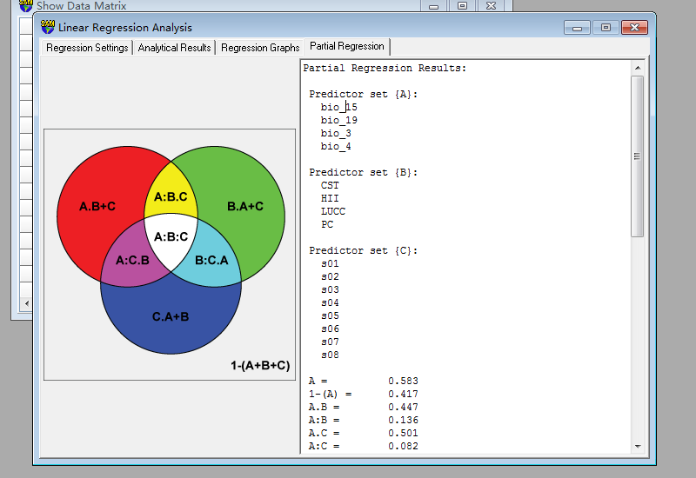Partial Regression Results:

Predictor set {A}:

bio_15

bio_19

bio_3

bio_4

Predictor set {B}:

CST

HII

LUCC

PC

Predictor set {C}:

s01

s02

s03

s04

s05

s06

s07

s08

A = 0.583

1-(A) = 0.417

A.B = 0.447

A:B = 0.136

A.C = 0.501

A:C = 0.082

A.B+C = 0.303 a

A:B+C = 0.28

B = 0.163

1-(B) = 0.837

B.A = 0.028

B:A = 0.136

B.C = 0.223

B:C = -0.06

B.A+C = 0.025 b

B:A+C = 0.138

C = 0.273

1-(C) = 0.727

C.A = 0.191

C:A = 0.082

C.B = 0.332

C:B = -0.06

C.A+B = 0.188 c

C:A+B = 0.084

A+B = 0.61

1-(A+B) = 0.39

A+B.C = 0.526

A+B:C = 0.084

A+C = 0.774

1-(A+C) = 0.226

A+C.B = 0.636

A+C:B = 0.138

B+C = 0.496

1-(B+C) = 0.504

B+C.A = 0.216

B+C:A = 0.28

A+B+C = 0.799

1-(A+B+C) = 0.201

A:B.C = 0.198 d

A:C.B = 0.144 e

B:C.A = 0.002 f

A:B:C = -0.062 g